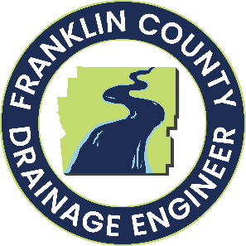
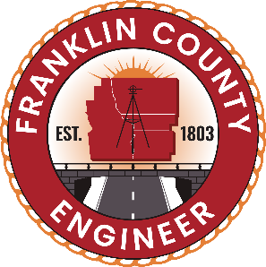
Project Information Sheet

Richardson Road Drainage Improvement Project

Raduege-Snyder Ditch Drainage Improvement Petition
Ohio Revised Code Chapter 6131
Project Overview
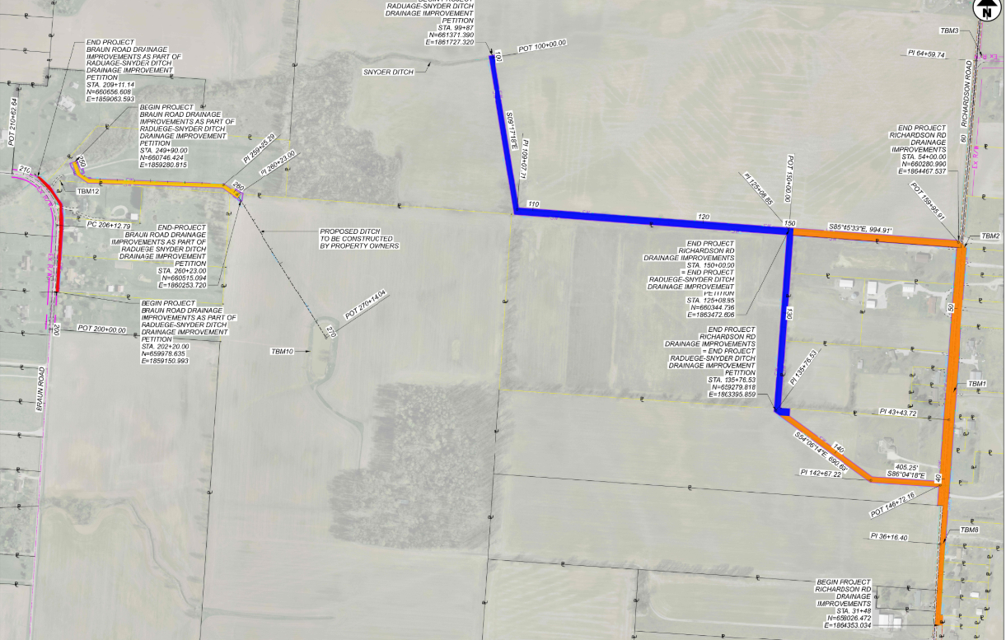
July 23, 2026
Project Description:
- The Raduege-Snyder Ditch Drainage Improvement Petition was filed on March 23, 2023, and includes signatures from property owners from 17 different parcels.
- This project follows the drainage improvement petition process outlined in Ohio Revised Code Chapter 6131.
- This project has been split into two plan sets: Raduege-Snyder Ditch and Richardson Road. Raduege-Snyder Ditch must be constructed prior to Richardson Road Storm Sewer.
Project Purpose:
  - In response to a drainage improvement petition “generally improve the drainage, both surface and subsurface, to a good and sufficient outlet by replacing, repairing, or altering the existing improvements as required and creating new surface and subsurface drainage mains or laterals, as requested by this petition, in order to mitigate crop loss due to flooding and prevent damage to existing home sewage treatment systems. “

Richardson Road

z
Potential Impacts:
Utilities
- Minor utility relocations needed, mostly along Richardson Road.
Right-of-way
- Permanent drainage easements along the drainage improvements would be established via a recorded plat.

Raduege-Snyder Ditch:
Includes the installation of 4,449 feet of drain tile, 671 feet of storm sewer, and various storm structures.
Design | $98,399
Construction Inspection | $50,000
Construction | $2,015,685
Maintenance Startup (3%) | $60,470.55
Raduege-Snyder Total | $2,224,554.55


Approval:
- The decision whether to approve the petition will be made by the Franklin County Board of Commissioners at a final hearing (date to be determined).
Funding:
- The Franklin County Engineer’s Office is applying for Ohio Public Works Committee (OPWC) 2027 grant funding for Raduege-Snyder Ditch and Richardson Road improvements.
- The OPWC grant is competitive. Submitting a grant application does not guarantee funding.
- Costs not covered by grant funding for Raduege-Snyder Ditch will be distributed amongst the benefiting property owners if the Board of Commissioners approves the petition at the final hearing.
- Costs not covered by grant funding for Richardson Road Storm Sewer will be paid for by Franklin County.
Braun Road
Raduege-Snyder Ditch
Richardson Road Storm Sewer:
Includes the installation of 5,400 feet of storm sewer and ditch grading.

Design | $ 98,400
Construction Inspection | $ 50,000
Construction | $ 1,540,890
Richardson Road Total | $ 1,689,290

Project estimates are subject to change.
Richardson Road Storm Sewer

